Lockyer Hire PTY lTD

TRANSPORT MANAGEMENT Plan

Contents
COMMITMENT AND POLICY 3
Purpose 3
Code of Conduct 3
Transport Rules 3
Licence 3
Driving 4
Light Vehicles / Utes / Sedans 4
Safety Devices 4
Flashing Beacons 4
Two-way Radios 4
Seats and Seat Belts 4
Safe operations of Vehicles 4
Checking vehicles before initial use – Pre Start Checks 5
Checking the Vehicle before Operation 5
Boarding and Alighting from Vehicles 5
No smoking in vehicles 5
Mobile Phones 5
Vehicle Operation 5
Starting and Moving Off 5
Reversing 6
Driving under overhead structures and power lines 6
Operating near energised power lines 6
Traffic Control 6
Parking / Standing of vehicles 6
All Vehicles 6
Light Vehicles 6
Broken Down Equipment 7
Maintenance personnel working in close proximity to Vehicles and Mobile Equipment in motion. 7
Speed Compliance 7
Speed Limiters 7
Motion Maximum speeds 7
Mass, Dimension and Loading 7
Shifting Loads 7
Load Restraint Forces 8
Choose a vehicle suitable for the type of load. 9
Positioning the Load 10
The consequences of the load shifting or falling. 11
Direct Lashing 12
Direct lashing Angles 12
Lashing Positions 13
Lashing Capacities 13
Inspecting and using chains 14
Dangerous Goods 14
Leakage and spills 14
Fatigue Management 15
Sleeping in Cabs of Heavy Equipment 15
Loading and Unloading 15
Loading and Unloading equipment from vehicles 15
Maintenance of Vehicles 16
Ongoing maintenance of vehicles 16
Refuelling and Battery checking 16
Towing 16
Incident Reporting 16
Accountabilities 17
Responsibilities as an employee 17
In addition, it is required that all drivers: 17
Responsibilities as an employer 18
Driver Training 18
Delivery Procedures 18
Pre Delivery 18
Asses Equipment to be loaded 18
Loading machinery 19
Restrain machine for transport 19
Prepare for transport 20
Leaving Site 20
Delivery 20
Unloading machinery 20
Getting out of the truck 21
Unloading machinery 21
Pick up/ return Delivery 21
Return to yard 22
Expectations 22

COMMITMENT AND POLICY

Purpose
To provide guidelines to manage hazards arising from the operation of vehicles at Lockyer Hire Pty Ltd.

The Transport Rules apply to all personnel, contractors and visitors operating vehicles within Lockyer Hire.

Code of Conduct
The code of conduct for Lockyer Hire states that; “While driving company vehicles or own vehicles for work purposes, staff must comply with traffic legislation, be conscious of road safety and demonstrate safe driving and other good road safety habits”.
The following actions in company vehicles will be viewed as serious breaches of conduct and dismissal may be a consequence:
- drinking or being under the influence of drugs while driving
- driving while disqualified or not correctly licensed
- Reckless or dangerous driving causing death or injury
- failing to stop after a crash
- acquiring demerit points leading to suspension of licence
- Any actions that warrant the suspension of a licence.

Transport Rules
- Whatever the circumstances, you are responsible for the safety of your passengers and yourself. Furthermore, it is important to remember that you have a responsibility to exercise the utmost care towards other drivers and pedestrians.
- Be observant and try to anticipate traffic and pedestrian movements.
- Safety belts are to be worn at all times irrespective of the length of the journey, and the onus is upon the driver for the passengers to do likewise.
- Under no circumstances is a vehicle to be driven in an unsafe condition. Particular attention is to be paid to brakes, steering and tyres.
- In some locations, drivers of field service vehicles or other load carrying vehicles are required to carry out fortnightly inspection and report on the condition of their vehicle.
- All company vehicles should be fitted with suitable fire extinguishers and first aid kit.

Licence
- All personnel driving company vehicles are required to hold a current and valid driver’s licence for the vehicle to be driven.
- Any employee involved in an accident or losing his/her, licence due to the influence of alcohol whilst driving a company vehicle may be dismissed.
- In the event of an employee losing or having their licence suspended, it is to be reported to the supervisor and under no circumstances is a company vehicle to be driven by that employee.

Driving
- For Remote Areas: When employees are setting out on their journey, they are to call into their supervisor to inform their destination and estimated time of arrival. On arrival, they are to call in and report their safe arrival.
- Employees driving company vehicles are required to drive in a safe and responsible manner and to obey traffic rules at all times. Any fines or penalty for traffic infringements are to be paid by the employee. The company does not require you to drive outside the law and there is no excuse or reason to do so.
- In the event of a vehicle accident, employees are required to provide or arrange first aid as necessary, then to ensure that the accident site is left in a safe and clean condition. The accident is to be reported promptly to the supervisor and necessary insurance claim forms to be completed as instructed.
- When driving in country or remote areas, all company drivers are required to take a rest stop approximately every two hours.
- The combination of working and drive hours in a day are normally set at a maximum of 10 hours and the driver is expected to arrange travelling accommodation to avoid exceeding this limit.
- However, the conditions set out in point 5 above, are subject to local procedures within each region.

Light Vehicles / Utes / Sedans
- As per SWMS - Driving
- All light vehicles are to be roadworthy.
- When loading a vehicle, the load shall not exceed the OEM design for each vehicle (check vehicle OEM details). Loads should be placed evenly on the vehicle, with respect to heavier objects, place nearer the centre of the vehicle.

Safety Devices

Flashing Beacons
- When in a Construction site area or driving around the Workshop all vehicles less than 3 metres in height must:
- All equipment shall have an operational flashing beacon that must be used at all times when the vehicle is in use.

Two-way Radios
- All operations vehicles shall be equipped with two-way radios. Where two-way radios are not fitted or are defective a hand held radio will be required.
- No person shall use the two-way radios for any purpose other than official communication.
- Fire Extinguishers
- All vehicles must have a fire extinguisher.
- Segregation of People from Loads
- Loose objects shall NOT be carried in vehicles when being used for transporting personnel.

Seats and Seat Belts
- Safety belts are to be worn at all times.
- If the vehicle has been involved in an accident in which strain was placed in the belts, they are to be checked and will be replaced in the event of damage.
- Belts are to be checked periodically for damage or loosening at the buckles or anchor brackets.
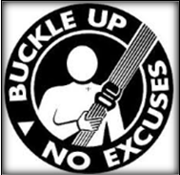

Safe operations of Vehicles
- All persons operating vehicles shall comply with all systems, Rules, Standards and Procedures established for the safe operation of that vehicle or class of vehicle.
- All vehicles shall be operated within the design parameters of that vehicle.

Checking vehicles before initial use – Pre Start Checks
- All vehicle types must be subjected to a safety inspection prior to initial use.
- All non-road registered vehicles must be subjected to a risk assessment prior to initial use.
- The Assessment must:
- Involve a cross-section of people who will use and maintain the equipment.
- Address all aspects of safe operation and maintenance including handling, driver vision, lighting, ergonomics, and methods of access and egress for anyone operating or performing maintenance on a vehicle.
- Ensure the Vehicle is operated within design parameters for that vehicle.

Checking the Vehicle before Operation
- All vehicles and equipment being driven or operated must have an appropriate Pre-Operational safety check prior to use. This will be carried out by a walk-around inspection based on appropriate checklists for the vehicle being used. The operator is to record that the inspection has been carried out. All defects must be reported. Where a defect introduces a risk to the safe operation of that machine, the equipment must not be operated until it is repaired. Where an inspection is required to be carried out on a truck that is loaded, the operator shall not go within the footprint of the loaded truck while carrying out the inspection.
- All light vehicles shall have a documented pre-operational safety check conducted once in every 24 hour period where operational use is continual. At other times prior to use, the operator shall conduct a walk around inspection. Any defects found shall be documented and actioned according to maintenance procedures.

Boarding and Alighting from Vehicles
- No person shall board or alight from a vehicle other than by the steps or ladder-ways provided for that purpose.
- Any person boarding or alighting shall maintain three points of contact with the access way at all times.

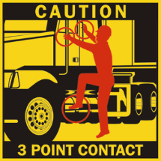

No smoking in vehicles
- Smoking in the cabin of all vehicles and equipment is strictly prohibited.

Mobile Phones
- Mobile phones are only to be used with approved hands fee kit when vehicle is moving.
- In all other circumstances the vehicle is to be stationary, or brought to a stop as soon as it is safe to do so when using a mobile phone.

Vehicle Operation

Starting and Moving Off
- Drivers and operators of all vehicles must check that the vehicle and area required for manoeuvrings is clear of obstructions and persons prior to moving off. Vehicles must not be driven through any blind area unless the driver has immediately checked that the area is clear or the operator is under the direction of an identified observer who can safely control the move. Drivers of heavy vehicles must signal their intentions when starting and moving off. This will be done by using the vehicle horn, and using traffic indicator lights where fitted. Drivers must drive forward if possible.

Reversing
- Heavy Vehicle Operators shall not reverse the vehicle unless:
- the operator has personally checked the rear and sides of the vehicle to ensure it is clear of any other vehicles or obstruction, and
- the operator has a clear view of the sides and to the rear of the vehicle, through the vehicle’s mirrors; or
- the operator receives directions from another person who has a clear view of the sides and to the rear of the vehicle, and
- Pre-movement warning signals are given.

Driving under overhead structures and power lines
- Where overhead structures are installed about the mine, an assessment of the risk of mobile equipment contacting those structures is to be carried out and appropriate controls used to prevent this from occurring.
- Vehicles may only pass under overhead power lines:
- At designated crossing areas where height barriers and signs indicate safe clearance, voltage, and any other associated matters.
- At other areas only after a risk assessment, where the controls have been approved after reference to safe clearance standards.

Operating near energised power lines
- No person shall operate any vehicle with sufficient height to contact overhead power lines, within 10m of an overhead transmission line unless a Working Near Power Sources permit has been completed.

Traffic Control
- All vehicles are to be driven in a safe and sensible manner, having due regard for other vehicles, the road and weather conditions existing at the time.
- All vehicles must only be operated on a stable and safe surface appropriate for the vehicle and the work being undertaken.
- Vehicle operators and drivers are to obey all signs and traffic rules. Vehicles must not be driven in areas that they have been prohibited from.
- Vehicles or equipment which in the view of the person accountable for the area represent a hazard to other traffic (e.g. moving too slowly or poorly lit) must be escorted unless other steps are taken to reduce the risk to other road users.

Parking / Standing of vehicles

All Vehicles
- In designated parking areas where available.
- Vehicle drivers shall ensure their vehicle is parked in a fundamentally stable position before alighting. This means that the vehicle will not roll or move when all gears are disengaged and brakes are released. A test to ensure the vehicle is fundamentally stable shall be conducted. Then the park brake is applied and all ground-engaging implements (such as buckets or blades) are lowered to the ground.
- Wheel chocks of a suitable size may be used; however an attempt to park fundamentally stable should always be the first priority.
- Do not park vehicles where they may cause a hazard to other traffic.
- Do not leave light vehicles unattended whilst the engine is running.
- Operators of equipment must follow appropriate isolation procedures and maintain line of sight of persons working in or around their vehicle or equipment, while there is any risk to those persons.
- If vehicles are required to park in close proximity to other vehicles, an attempt should be made to park or stand parallel to or out of the line of fire where ever possible,

- When pedestrians are working on or near roadways, suitable warning signage shall be erected. It is the responsibility of the vehicle operator to stay clear of the pedestrians.

Light Vehicles
- Light vehicles should be left in a fundamentally stable position, engine off, left in gear or in PARK as applicable with the hand brake applied.
- For the operation of work lights during the hours of darkness, service vehicles may be left running in a fundamentally stable position provided that:
- Suitable wheel chocks are used
- The vehicle operator is working in the work lights of that vehicle at all times(i.e. vehicle is not left unattended). Light vehicles should be parked in the line of sight of heavy vehicle and equipment operators, irrespective of whether or not they are being operated at the time.
- Do not park in any area in which any machine is operating unless the operator has been notified and approves that the parking area is suitable.

Broken Down Equipment
- Hazard lights on the equipment, flashing lights, witches hats or a safely positioned lighting plant may be used to demarcate any vehicle or equipment that is broken down on a road during hours of darkness or poor visibility.
- If broken down equipment cannot be moved within a reasonable timeframe a safety barrier may be constructed around it to provide suitable protection for Maintenance personnel and other operator equipment.
- Where other procedures for parking have been put in place then the requirements of those procedures will be complied with.

Maintenance personnel working in close proximity to Vehicles and Mobile Equipment in motion.

For Maintenance personnel interacting with vehicles or other mobile machinery as part of their work, an exclusion zone of a minimum 3 metres, or greater distance with consideration of speed and operator visibility, must be maintained whilst the vehicle is in motion. Where pedestrian interaction is required with a suspended load, appropriate task permit including the use of aids or tag lines must be used to ensure the exclusion zone is maintained.

Mobile vehicle operators must maintain visual contact with all interacting pedestrians whilst the vehicle is in motion.

For any job task where the exclusion zone cannot be maintained then controls to manage the risk must be developed and implemented. This may be done via a Safe Work Procedure or a Risk Assessment.

Speed Compliance

Speed Limiters
Trucks fitted with speed Limiters are not to be tampered with in any way. All speed limiters will be checked upon yearly inspection and during regular maintenance schedules. Issues with speed limiters to be noted on weekly vehicle check sheets and discussed with Service Manager immediately.

Motion Maximum speeds
Risk can be reduced by:
• observing speed limits
• driving at a speed appropriate for the conditions
• responding to speed warning alerts
• adjusting arrival times to compensate for delays
• planning trips on the basis of time within speed limits.

Mass, Dimension and Loading

Shifting Loads
When moving a vehicle and its load are subjected to forces caused by changes in speed, direction and slope.
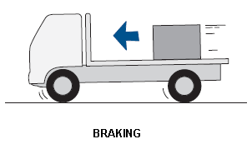
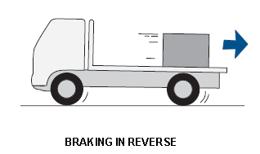
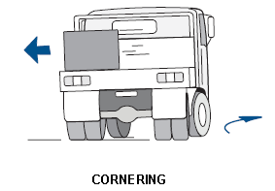
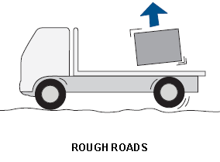
Diagrams sourced from Load Restraint Guide published by National Transport Commission 2004.

Load Restraint Forces
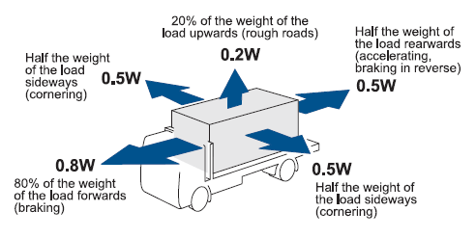
Every load must be restrained to prevent unacceptable movement during all expected conditions of operation.

Choose a vehicle suitable for the type of load.
A vehicle must be chosen based on the suitability for the load being carried. The table below highlights vehicle weight, height and carrying capacities.
Vehicle | TARE | GVM | GCM | ATM | Payload / (Maximum Load Rating)
 | Total Mass un laden | Gross Vehicle Mass | Gross Combination Mass
Isuzu Tilt Tray | 8640kg | 15000kg | 24000kg | N/A | Tilt Tray excluding Trailer | 6360kg
Mitsubishi Delivery Truck | 1855kg | 4495kg | 7995kg | N/A | Delivery Truck excluding Trailer
Isuzu DMAX Ute | 1660kg | 2950kg | 5950kg | N/A | Ute excluding Trailer
 |  | *Weights as recorded on individual compliance plates.
Trailer / tray load carrying dimensions
Vehicle | Length | Width
Isuzu Tilt Tray | 7.6m | 2.5m
Mitsubishi Delivery Truck | 5.3m | 1.9m
Isuzu Dmax Ute | 5.65m | 1.9m

A long load should be carried on a vehicle with a suitable length.
A load which projects beyond the side or rear of a vehicle must have a flag affixed to highlight.
A load should not be carried if any of the following are exceeded:
The vehicle manufacturers rated axle load capacity.
The vehicle manufactures rated Gross Vehicle mass (As listed above)
The vehicle manufacturers rated Gross Combination Mass (As listed above)

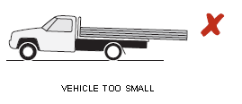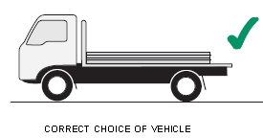

Positioning the Load
- Incorrect positioning of the load on a vehicle can result in a significant safety risk.
- The load must be positioned to:
Maintain adequate stability, steering and braking, and not overload tyres and axles.

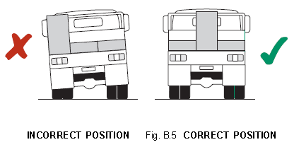
The centre of mass of the load should be in front of the rear axle of a semi-trailer to
Provide enough weight on drive axles of the prime mover for traction and stability.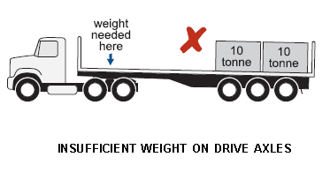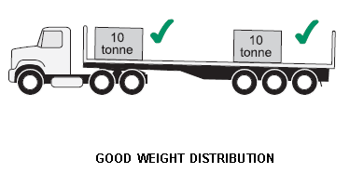

The consequences of the load shifting or falling.
- Loading operators should give regard to the nature and density of the material being loaded, particularly when changing from one material type to another.
- The methods utilised to manage the loading of trucks include:
- Feedback by loading operator to truck driver on irregularities in the load Truck payload monitors
- Feedback by truck driver to loading operator
- Visual monitoring of loads by other operators and Supervisors Monitoring of spillage by operators and Supervisors
- Loading operator and truck driver training programs Occasional weigh scale checks for haul trucks.

DOs AND DON’Ts
DO make sure that the vehicle’s load space and loading deck are suitable for the
type and size of the load.
DO check the weight of the load to be carried.
DO check the positioning of the load along the vehicle.
DO consider the positioning of the load after partially loading or partially unloading
the vehicle.
DO position the load evenly across the vehicle.
DO provide extra restraint for tall loads.
DON’T overload your vehicle or its individual axles.
DON’T load your vehicle too high.
DON’T overload the steer axle by placing the load too far forward.
DON’T reduce the weight on the steer axle by placing the load too far back.
DON’T allow the load to project dangerously towards the cabin or outside the vehicle.
DON’T place rectangular dunnage on its narrow face.

TYPICAL FRICTION LEVE

Load Friction

Wet or greasy steel on steel | VERY LOW
Smooth steel on smooth steel | LOW
Smooth steel on rusty steel | LOW TO MEDIUM
Smooth steel on timber | MEDIUM
Smooth steel on conveyor belt | MEDIUM
Rusty steel on rusty steel | MEDIUM TO HIGH
Rusty steel on timber | HIGH
Smooth steel on rubber load mat | HIGH

Direct Lashing

Direct lashings are ideal for restraining slippery loads and loads on wheels / drums.
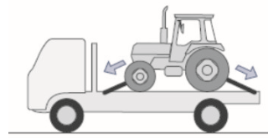
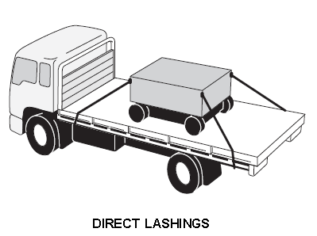

Direct lashing Angles
Lashings must be angled in directions opposite to any expected load movement. As per example below.
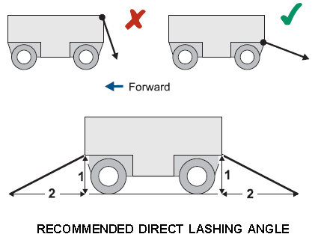

Lashing Positions
As highlighted below the lashings can be attached at any position along the load. When opposing direct lashings are attached at one end the load, vertical tie down lashings are required at the opposite end of the load to prevent sideways movement.
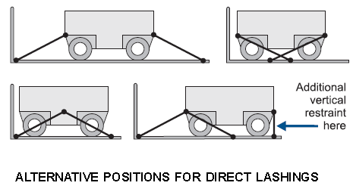

Lashing Capacities
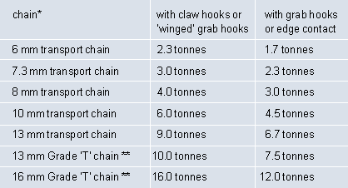

Inspecting and using chains
Chains and dogs are to be inspected on a weekly and recorded on vehicle weekly inspection checklist. This is to ensure that all restraints are kept in good working order.
Inspection to include:
- Any signs of wear at load bearing points.
- Excessive play in any ratchets
- Impaired rotation of ratchets.
- Chains to be inspected for any signs of wear, twisting, stretching, nicks or grouping.
- Check that safety catches are operational.
- Ensure that chains are protected from any sharp corners on loads.

Do not use equipment weakened by worn or damaged components, for securing loads. If there is a doubt about safety it should be replaced.

Dangerous Goods
Occasionally small quantities of dangerous goods will be carried. Care must be taken not to exceed quantity thresholds to control risks and meet legislative requirements.
Class 1 Explosive
Not to be carried under any circumstances.
Glass 2 Gasses
If any quantity of Flammable (2.1) or Toxic (2.3) gasses or any Packaging Group 1 products are carried the total quantity must not exceed 250 Kg (L)
Any dangerous goods in individual bulk containers: Limits of 500Kg (L) per container. Total of all mixed classes not to exceed 1000Kg (L)

Compatibility and segregation issues arrive when different classes are carried.

Leakage and spills
- Any accidental leakage or spillage must be reported to the supervisor.
- Clean up the spillage according to instructions in the MSDS
- No chemicals are allowed to run off into stormwater drainage systems.

Fatigue Management
The purpose of Lockyer Hire Fatigue Management policy is to establish the requirements for managing fatigue effectively. It is intended that this policy will reduce the risk of fatigue-related injuries and incidents in the workplace. This policy applies to all staff—especially those whose work involves shift work—extended hours and on-call arrangements.
Fatigue Management Exert - Key areas of consideration.
- Systems and methods of compliance
- Trip rostering practices
- Commercial vehicle driver readiness for duty policies
- Commercial vehicle driver health practices
- Workplace conditions
- Training and education practices
- Requirements for the responsible person at the workplace and other staff involved in the management, operation, administration, participation & verification.
- Documentation and records
- Management of incidents

Sleeping in Cabs of Heavy Equipment
- For the purposes of fatigue management, sleeping in the cab of equipment shall be permitted providing:
- The equipment is not required for production or maintenance purposes and permission is obtained from the Supervisor.
- Prior to resuming work, a full walk around inspection must be complete.
- The equipment two-way radio must be left on and at an audible level for emergency purposes.
- Under no circumstances is sleeping in the cab permitted while the equipment is being refuelled or other maintenance activities are taking place.
- Monitoring and managing work schedules to ensure they do not encourage unsafe driving practices by:
- recommending staff to have 10 hours’ minimum continuous rest and 11 hours’ maximum driving time every 24 hours
- Requiring non-commercial drivers to take 10-minute breaks every two hours of driving.
- Taking into account individual drivers’ needs by:
- Requiring staff to keep driving logs that are regularly checked by a supervisor or manager. This is also a requirement for Inland Revenue purposes.
- For any job task where an exclusion zone cannot be maintained then controls to manage the risk must be developed and implemented. A risk assessment and/or Safe Work Procedure must be developed and approved by the Supervisor prior to implementation.

Loading and Unloading

Loading and Unloading equipment from vehicles
The following guidelines should be considered for the process of loading and unloading equipment;
- Risk assessment
- Prior to loading / unloading a particular item of plant the float shall be parked in an area that enables safe, level, firm access for the loading / unloading operation. The area(s) shall be clear of any immediate operational activities
- If there is any doubt to the gradient of the area, then wheel chocking of the float and/or prime mover shall be considered and implemented
- The operator of the machine to be loaded/unloaded shall ensure that all implements are positioned such, that there will be no contact with the ground as the machine transitions from ground to float ramps or float damage when moving from ramps to flat bed or the reverse
- Before the float moves off, the driver shall ensure that the machine security, (chaining, if deemed applicable) is sufficient for the entire relocation route.

** All machinery to be securely fastened prior to dispatch. Do not secure load the evening, day or weekend before. All loads to be secured and checked prior to dispatch **

Maintenance of Vehicles

Ongoing maintenance of vehicles
- All mobile equipment must be placed on a planned maintenance program when commissioned for use.
- Routine maintenance and repairs
- Service of the vehicle is to be carried out in accordance with the manufacturer’s schedule and charged to the Fleet Card.
- Small items such as tail light globes, brake adjustments, trafficator lights and other items affecting safety must be rectified immediately.
- servicing the vehicles according to manufacturers’ recommendations
- setting up procedures where employees check vehicles’ oil, water, tyre pressures and general cleanliness on a monthly basis, then record the inspections
- Keeping maintenance schedules in the glove boxes of all vehicles, which are completed each time the vehicles are serviced in any way
- following the maintenance schedules in the vehicles’ manuals
- Setting up a procedure to identify and rectify faults as soon as practicable.
- Maintenance personnel, when required to work on equipment on the mine site shall notify the respective Supervisor if they are taking working equipment out of production.

Refuelling and Battery checking
- No smoking or naked flames are permitted within 20 m of any refuelling, battery checking or battery charging areas.
- Refuelling of heavy vehicles or equipment shall only be done in accordance with the

Towing

- Towing other vehicles, trailers or lighting plants
- No vehicle will tow equipment unless it is engineered to do so. When towing a trailer the hitch must be connected correctly and the safety mechanism must be engaged.
- If the towing is being conducted outside daylight hours, or in times of reduced visibility then either:
- Trailer shall have an operational and effective tail and brake light, or
- The towing vehicle shall be fitted with a readily seen flashing beacon where required, or The area
- Lighting shall be sufficient to ensure compliance with all of the above
- When towing other vehicles or lighting plants the Towing Procedure shall be followed. The driver of the vehicle is responsible to ensure compliance with all of the above.

Incident Reporting
- What employees are to do if there is a crash in a company vehicle
- Immediately stop your vehicle at the scene or as close to it as possible, making sure you are not obstructing traffic. Ensure your own safety first. Help any injured people and call for assistance if needed.
- Try to get the following information:
  - Details of the other vehicle(s) and registration number(s)
  - Name and address(es) of the other vehicle owner(s) and driver(s)
  - Name and address(es) of any witness(es)
  - Name of insurer(s).
- Give the following information:
  - Your name and address and company details, If you damage another vehicle that is unattended, leave a note on the vehicle with your contact details.
- Contact the police:
  - If there are injuries
  - if there is a disagreement over the cause of the crash
  - if you damage property other than your own
  - If damage to the vehicle looks to be worth more than $2500.
  - Follow-up
  - If there is an injury or major damage, report the crash to your manager as soon as you can

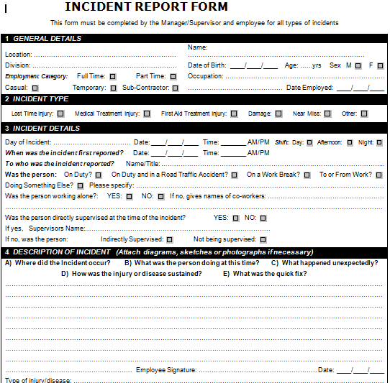

Accountabilities

Responsibilities as an employee
Every driver of a company vehicle will:
- Ensure they hold a current driver licence for the class of vehicle they are driving and this licence is carried when driving a company vehicle
- Immediately notify their supervisor or manager if their driver licence has been suspended or cancelled, or has had limitations placed upon it
- Be responsible and accountable for their actions when operating a company vehicle or driving for the purposes of work
- Display the highest level of professional conduct when driving a company vehicle
- Regularly check the oil, tyre pressures, radiator and battery levels of company vehicles they regularly use
- Comply with traffic legislation when driving
- Assess hazards while driving and anticipate ‘what if’ scenarios
- Drive within the legal speed limits, including driving to the conditions
- Wear a safety belt at all times
- Never drive under the influence of alcohol or drugs, including prescription and over the counter medication if they cause drowsiness – to do so will merit disciplinary measures
- Avoid distraction when driving – the driver will adjust car stereos/mirrors etc. before setting off, or pull over safely in order to do so
- Report any near-hits, crashes and scrapes to their manager, including those that do not result in injury, and follow the crash procedures outlined in this policy
- Report infringements to a manager at the earliest opportunity
- Report vehicle defects to a manager before the next vehicle use.

In addition, it is required that all drivers:
- Take regular and adequate rest breaks, at least every two hours
- stop when tired
- Plan their journeys, taking into account pre-journey work duties, the length of the trip and post-journey commitments
- Stay overnight if driving time and non-driving duties exceed 10 hours in one day.

If an employee is driving their own vehicle for the purposes of work, the same policies apply. In addition:
- The employee must seek the employer’s agreement before using their vehicle for work
- The car must be legally registered, warranted and insured for the purposes of work – the employee must show evidence of this on request
- The employee must not carry loads for which the vehicle is unsuited, nor may they carry more passengers than for whom there are seat belts
- The vehicle must not be used in conditions for which it was not designed (such as off-road).

Responsibilities as an employer
The employer will take all steps to ensure company vehicles are as safe as possible and will not require staff to drive under conditions that are unsafe and/or likely to create an unsafe environment, physical distress, fatigue, etc.
The employer will do this by undertaking the following tasks:

- Giving priority to safety features when selecting new vehicles, including:
- Only buying and/or hiring vehicles that rate four or more stars on the ANCAP (Australasian New Car Assessment Program) tests
- Choosing vehicles with ESC (Electronic Stability Control), ABS brakes and side head-protecting airbags
- Only buying and/or hiring vehicles that are light coloured
- Fitting all vehicles with a first aid kit, fire extinguisher, reflective vest, torch and emergency triangle.

Driver Training
Identifying driver training needs and arranging appropriate training or retraining, including providing:
- A thorough induction to the company’s road safety policies and procedures
- Driver training opportunities to all staff
- Driver assessment and required training as part of all staff inductions
- Advanced driver training or specific practical training as required and identified
- Regular staff seminars or refresher meetings on safety features, fatigue, driver responsibility, drink-driving and fuel-efficient driving
- Driver training log updates on personnel files.

Encouraging safe driving behaviour by:
- Not paying staff speeding or other infringement fines
- Forbidding the use of mobile phones in vehicles while driving
- Encouraging regular breaks while driving
- Providing taxis and designated drivers to and from work social events
- Providing food and non-alcoholic drinks at work functions
- Encouraging the use of taxis and buses whenever necessary
- Ensuring the employer is informed if existing staff become unlicensed.

Delivery Procedures

Pre Delivery
- Commence delivery process on or before pre-determined start time as advised by Hire Coordinator or his/her designated replacement.
- All instances of inability to meet this deadline to be communicated to the Hire Coordinator or his/her designated replacement immediately. Any time variances to be ‘made up’ in consultation with Hire Coordinator.
- Delivery paperwork to be obtained. Hire Coordinator to advise unit number, address, map reference and site contact number.

Asses Equipment to be loaded
- Check weight and size of machine to ensure suitable truck / trailer combination is utilised. Ensure suitable vehicle combination/ capacity is utilised.
- Check height of machine to ensure safe to transport.
- Check overall width of machine (use oversize sign if required)
- Determine correct method of loading (Plan Safe Load)
- Make sure machine is clean and free from debris prior to loading.
- Ensure rotating beacon is secured to unit.
- Decide on correct equipment to be used to restrain load. i.e. chains, dogs, straps.
- Use steps and handles provided to climb into / onto equipment. (3 Points of Contact)
- Familiarise yourself with the controls of the machine prior to loading – if in doubt make phone call / ask for assistance.
- Operate machinery to rear of tilt tray and prepare for winching.
- Operate machinery to rear of ramps and prepare for loading.
- Setup For loading / attach winch
- Always wear gloves when working with winch and load binders.
- Make sure the rear of the truck is clear and that no one can enter your safe working zone.
- Ensure ramps / tray is setup as level as possible.
- Attach winch cable where appropriate.
- Take up slack with winch remote. Only use remote when you have a clear and unobstructed view of work area. Always check work area to ensure loading can commence safely.

Loading Equipment
- Unit to be loaded with all relevant details checked and confirmed. i.e. Visual Pre delivery inspection completed. ID number confirmed.
- Access machine using 3 points of contact and handles provided to climb into / onto machine. When seated apply seatbelt.
- From the control centre (seated position) drive machine up tray and ramps slowly and apply winch )if appropriate) in sync to ensure safe transfer of macine
- Carefully but deliberately, drive/winch unit onto ramps / tray. Stopping when the unit is in a safe position for transport.
- When parked correctly shut down machine correctly and apply park brake. Make it it is safe and disembark from the unit ensuring you use 3 points of contact.
- Take care when walking on tray / deck and be alert for and slip fall hazards.
- Unit to be loaded with all relevant details checked and confirmed. i.e. Pre delivery inspection completed. ID number confirmed.

Restrain machine for transport
- If you have a wide load check overhang, make sure that load is within the limits (rectify of required i.e. same overhand both sides)
- Always wear gloves when working with load binders.
- Apply appropriate chains; if unsure refer to NTC load restraint guide or contact Hire Controller for advice.
- When applying chains to tie down machines always use front tow pints (lugs) and chain toward the rear of the tray. Apply chains from rear tow points towards the front of the tray. The chains will cross over, but you will have les chance of damaging pivot or steering of machine.
- Always stand on firm ground when applying load binder dog ratchet. Watch out for crush and impact zones.
- When 4 point of restraint is complete, stow tray and ramps. Release tension on winch prior to transport.
- Walk around truck and check load to ensure that it is secure before transport.
** All machinery to be securely fastened prior to dispatch. Do not secure load the evening, day or weekend before. All loads to be secured and checked prior to dispatch **

Prepare for transport
- Measure height (where required) of load and tray to ensure legal requirements for transport prior to mapping your route.
- Walk around truck once again to ensure everything is safe for movement.
- Ensure deck / tray is free from debris
- Confirm destination checking for height and weight restrictions. Check travelling timeframes if required (Wide load)
- Driver to phone customer re additional information, directions and/or to confirm best access points if not listed on paperwork.
- Any potential problems to be communicated to Hire Coordinator or his/her designated replacement. Hire Coordinator or his/her designated replacement to advice of revised delivery plan as soon as practicable.

Leaving Site
- Ensure lights / rotator are working prior to departure (if oversize load)
- Observe worksite conditions
- Indicate intentions
- Move into flow of traffic when safe to do so.
- Observe all traffic regulations whilst travelling to drop off location.
- Constantly observe load to ensure it is secure in transit. Allow for camber in road, pay attention to poles, trees and roadside signage.
- Delivery to proceed
- Ensure deck / tray is free from debris

Delivery
- Any problems or instances of inability to meet this deadline to be communicated to the Hire Coordinator or his/her designated replacement immediately. Hire Coordinator or his/her designated replacement to advice of revised delivery plan as soon as practicable.
- On arrival to site, loading area to be assessed for suitability and safety. All areas of concern to be communicated to Site contact. If site contact unavailable and a suitable replacement or authorized person is not contactable communicate to Hire Coordinator or his/her designated replacement. Hire Coordinator or his/her designated replacement to advice of revised delivery plan as soon as practicable.
- Delivery documentation to be signed by site contact. Where a delivery is of a last minte nature the “Equipment Receipt’ books are to be utilised in replace of Syrinx based Hire Contracts.

Unloading Machines
- If drop off point is a worksite of yard, follow site rules. (may need induction)
- Do a visual check of site – Ensure safety for yourself and others.
- Activate warning devices (notify traffic / pedestrians of your intensions) as early as possible then turn on hazard lights if required.
- Ensure the truck / trailer is located on flat even ground that is suitable to crate a safe work zone.
- Ensure there is enough room for safe transfer of machine.

Getting out of the truck
- Visually check for hazard/ risk prior to exiting truck.
- Step out of truck backwards using 3 points of contact.
- Do not jump out of cabin.
- Ensure high visibility clothing is worn at all times when out of truck.
- Maintain constant awareness of hazards and risk is the environment. Assess the dangers of the task and take appropriate actions as needed. (Complete risk assessment if required)
- Prepare for unloading
- Position truck on flat even surface away from curbs/ gutters to allow for safe transfer of machine.
- Remove all flags and warning devices.
- Always wear gloves when working with binders and chains.
- Preparation for unloading must ensure safety for you and others. A safe work zone / barrier may need to be set. Lower ramps / tray. (Watch out for crush / impact zones)
- Tension winch in preparation for unloading (before release of restraints)
- Always stand to the side of the truck on firm ground to release load binders / chains. Release binders in sequence. When removed stow all equipment correctly.

Unloading Machine
- Delivery to be completed as instructed maintaining safe work practices.
- Take care when walking on tray. Enter machine using 3 points of contact.
- Start machine and place machine in low speed and gradually drive machine off tray / down ramps. Release winch in sync.
- Once machine is on level ground and clear of tray / ramps move machine to safe area and park on flat level ground. Apply the brake, make safe and shut down machine.
- Exit machine using 3 points of contact.
- Raise tray and secure ramps in transport position. Check tray for oil spills, clear all debris prior to leaving site.
- Stow all tools and equipment away safely for transit.
- Site contact to be run through basics of operating equipment safely.
- Obtain signature from site contact confirming receipt of equipment.
- Upon completion of delivery, communicate back to Hire Coordinator for work plan update. Hire Coordinator or his/her designated replacement to advise of next work/job, or revised delivery, plan as soon as practicable.

Pick up/ return Delivery
- Pick up / return Delivery paperwork to be obtained, quantities documented and relevant details confirmed
- Commence pick up/return delivery process on or before pre-determined start time as advised by Hire Coordinator or his/her designated replacement.
- All instances of inability to meet this deadline to be communicated to the Hire Coordinator or his/her designated replacement immediately. Any time variances to be ‘made up’ in consultation with Hire Coordinator.
- Driver to phone customer re additional information, directions and/or to confirm pick up /return delivery.
- Any potential problems to be communicated to Hire Coordinator or his/her designated replacement. Hire Coordinator or his/her designated replacement to advise of revised delivery plan as soon as practicable.
- On arrival to site, loading area to be assessed for suitability and safety. All areas of concern to be communicated to Site contact. If site contact unavailable and a suitable replacement or authorized person is not contactable communicate to Hire Coordinator or his/her designated replacement. Hire Coordinator or his/her designated replacement to advise of revised delivery plan as soon as practicable.
- Any problems or instances of inability to meet this pick up/ return delivery deadline to be communicated to the Hire Coordinator or his/her designated replacement immediately. Hire Coordinator or his/her designated replacement to advise of revised delivery plan as soon as practicable.
- Upon completion of pick up/return delivery, communicate back to Hire Coordinator for work plan update. Hire Coordinator or his/her designated replacement to advise of next work/job, or revised delivery, plan as soon as practicable.

Return to yard
- Damaged plant to be noted and Hire Coordinator or his/her designated replacement notified as soon as practicable.
- Damaged plant to be quarantined in designated plant for repair/ goods not available for hire area.
- Non damaged plant to be stored in designated area.
- Relevant check sheets to be completed.
- Off Hire paperwork to be submitted to Hire Coordinator or his/her designated replacement as soon as practicable.
- Hire Coordinator or his/her designated replacement to advice of updated delivery plan.

Expectations
- Paperwork to be kept neat and tidy in designated folders.
- Designated uniform to be worn at all times

- Truck check sheets to be completed and returned to Hire Coordinator weekly

